**Solution Vision**

**for**

**Enterprise Data Management Capabilities - Master Data Management (MDM) Tool/Platform**

|  |  |
| --- | --- |
| Project Name | Enterprise Data Management Capabilities - Master Data Management (MDM)Tool/Platform |
| INVP # (if known) | 5917E |
| ITLT Sponsor | *Zentay, Charles* |
| IT Business Partner | *Brodsky, Ed* |
| Technical Ent Arch | N/A |
| Domain Architect | N/A |
| Solution Architect | N/A |
| Infrastructure Architect | Vargas, Keith |
| Security BP&I / Security Architecture | Mohammed, Khader |

|  |  |
| --- | --- |
| Document Version No. | 3.0 |
| Document Version Date | January 27, 2021 |
| Review Date | January 19, 2021 |
| Reviewed by: | ITGC |

**Contents:**

1 Purpose of this Document 3

2 Part 1: Business 3

2.1 Business Needs and Drivers 4

2.1.1 Stakeholders and their Concerns 5

2.1.2 Business Vision 5

2.1.3 Business Scenarios to be addressed 6

2.2 Constraints 6

2.2.1 Time Limits 6

2.2.2 Changes in the Business Environment 7

2.2.3 Organizational Constraints 7

2.2.4 External and Business Constraints 7

2.2.5 Budget Information and Financial Constraints 7

3 Part 2: Architecture 8

3.1 Purpose: Define Scope 8

3.2 Business Architecture 8

3.2.1 Users and User Experience Expectations 9

3.2.2 Current State Business and Application Model 9

3.3 Technical Objectives & Drivers 10

3.4 Technology Information 10

3.4.1 System Context 10

3.4.2 Use of Enterprise Assets 10

3.5 Information View 11

3.6 Options/Approaches 12

3.6.1 Security / Risk Information 12

3.6.2 Assessment Criteria of the Critical Success Factors 13

4 Options 13

4.1 Option 1: Reltio MDM Platform 14

4.2 Option 2: Informatica MDM Platform 16

5 Recommended Option and Rationale 20

6 Recommended solution 20

# Purpose of this Document

The Vision is created at the initiation of an IT request that has been reviewed by Strategic Planning to move into the Assessment Phase of a project lifecycle and provides a high-level, aspirational view of the end product. The purpose of the vision is to agree at the outset what the desired outcome should be for the project, so that the technical team can then focus on the critical areas to validate feasibility. Providing a Vision also supports stakeholder communication by providing a common document between business and IT teams to define the high-level project.

Normally, key elements of the Architecture Vision - such as the enterprise mission, vision, strategy, and goals - have been documented as part of some wider business strategy or enterprise planning activity that has its own lifecycle within the enterprise. In such cases, the activity in Phase A is concerned with verifying and understanding the documented business strategy and goals, and possibly bridging between the enterprise strategy and goals on the one hand, and the strategy and goals on the part of the enterprise that lies within the scope of the Baseline Architecture project.

Core purpose to Architectural Vision Document:

* To ensure that this evolution of the architecture development cycle has proper recognition and endorsement from the corporate management of the enterprise, and the support and commitment of the necessary line management
* To validate the business principles, business goals, and strategic business drivers of the organization
* To define the scope of, and to identify and prioritize the components of, the Baseline Architecture effort
* To define the relevant stakeholders, and their concerns and objectives
* To define the key business requirements to be addressed in this architecture effort, and the constraints that must be dealt with
* To articulate an Architecture Vision that demonstrates a response to those requirements and constraints
* To secure formal approval to proceed
* To understand the impact on, and of, other enterprise architecture development cycles ongoing in parallel

# Part 1: Business

Master data management (MDM) is a set of policies, standards, processes, governance, stewardships, and tools that combined create a commonly trusted, consistent, accurate, and controlled set of “master data” for critical business data from across internal and external data sources and applications

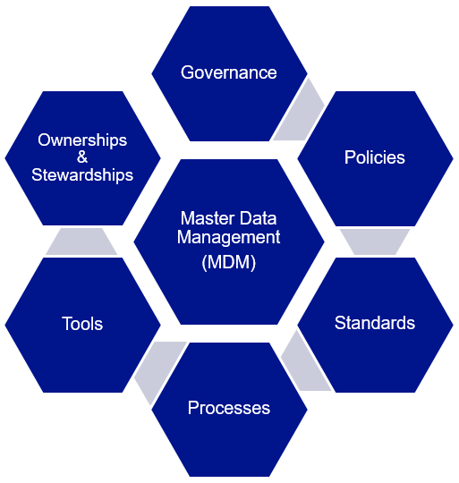

This main goal and objective of this initiative is to cover Master Data Management (MDM) tool/platform selection and making it available for the business use at National Grid. Please note that each master data domain implementation on the MDM platform will be covered in separate program initiative.

Benefits of Master Data Management:

* Creates centralized multi domain data repository by creating golden master records
* Creates an enterprise unique persistent identifier for each master data domain entity
* Avoids data duplication
* Improves data quality
* Improves data consistency and data standardization
* Increases data accuracy
* Provides better data compliance
* Enables data governance and data stewardship
* Offers better secure data access

Proposed Timeline for staging up the platform at National Grid:

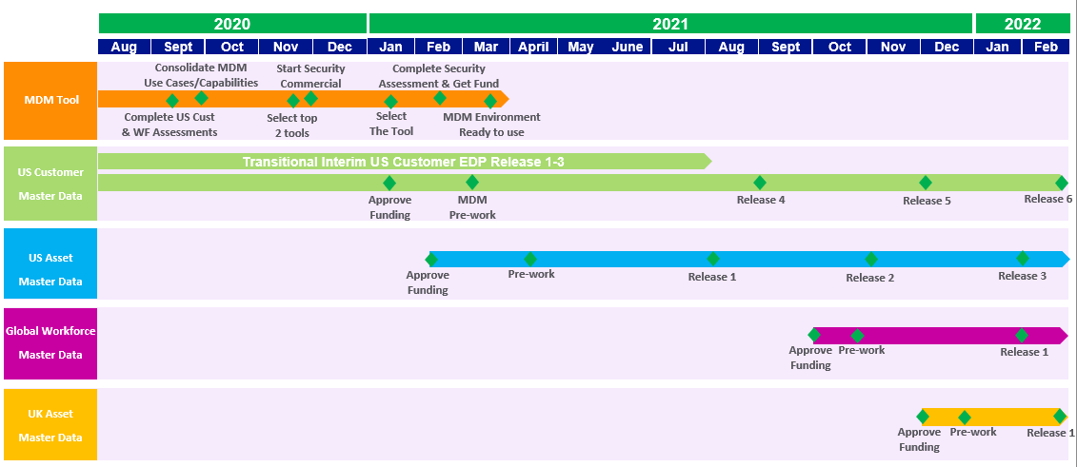

Early draft proposed timeline for data domains for MDM implementation:

**Note:** Each Master Data domain timeline shown above is a draft proposed timeline. Also priority of each data domain is not finalized yet. I am working figuring out the priority and once known, actual roadmap will be updated.

## Business Needs and Drivers

|  |
| --- |
| ***US Business Domain Demand​***   * **US Customer** – MDM requirement to build high quality, consistent, and complete master customer and meter data from numerous US customer systems of record like CRIS, CIS, CRM etc. and make them available to enterprise e.g. Customer Transformation, GBE, Digital Enablement (Nucleus, On My Way), Consolidation of Customer Data Sources to scalable centralized repository * **US Asset** – MDM requirement to build high quality, consistent, and complete master asset data from numerous US asset systems of record like Power Plan, GIS, Cascade, Computapole, STORMS, Maximo etc. and make them available to enterprise   ***UK Business Domain Demand​***   * **UK Customer** – MDM requirement to build high quality, consistent, accurate, and complete master customer data from numerous UK B2B customer systems of record CRM, SAP etc. and make them available enterprise wide * **UK Asset** – MDM requirement to build high quality, consistent, accurate, and complete master asset data from numerous UK asset systems of record like Ellipse, FieldReach, GeoGrid, ET Power Factory etc. and make them available to enterprise   ***Global Business Domain Demand***   * **Workforce** – MDM requirement to build high quality, consistent, accurate, and complete master workforce (Employee, Contingent worker, and Managed Service Provider workers) data from numerous workforce systems of record like SuccessFactor, FieldGlass, US/UK SAP etc. and make them available to enterprise e.g. GBE, Digital Enablement (On My Way). |

### Stakeholders and their Concerns

As per the “Fixing Data” paper presented in April 2020 to executives by Chief Data Officer Charles Zentay, unless we “Fix Data” our security, major programs, and financial and operational performance are at risk. In addition, clean, organized Data is like a common language and underpins Business Analytics and Digital Transformation. To overcome our data problems, the key components are (i) building upon the progress of Data BMS to improve capabilities of Data Governance & Stewardship; (ii) implementing standardized Data Tools & Platforms; and **(iii) driving Master Data Solutions in each major domain (Employee, Customer, Asset, Product, Vendor, and Finance). To ensure rapid action and coordination, it is imperative to agree on a “Hub-and-Spoke” operating model, an owner to drive Master Data for each major domain, and a holistic funding model.**

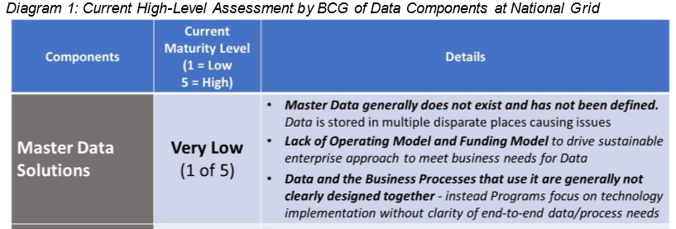

### Business Vision

The current state of Data at National Grid poses significant challenges for the company. It exposes us to security risks, has already impacted our major programs, and necessitates costly manual efforts to deliver our daily operational services. “Fixing Data” holistically (and no longer as one-off efforts) is imperative and urgent.

Unless we “Fix Data,” our security, major programs, and financial and operational performance are at risk. In addition, clean, organized Data is like a common language and underpins business analytics and Digital Transformation. To overcome our Data problem, the key components are

1. Building upon the progress of Data BMS to improve capabilities of Data Governance & Stewardship
2. Implementing standardized Data Tools & Platforms
3. driving Master Data Solutions in each major business data domains (Workforce, Customer, Asset, Product Vendor, and Finance)

### Business Scenarios to be addressed

National Grid does not currently have an enterprise Master Data Management (MDM) platform.

The following are the key business drivers:

* Multiple master data source systems but no universal unique Enterprise Persistent ID for any master data entity or centralized multi domain data repository
* Multiple data repository and data duplication
* Multiple master data quality and consistency issues
* US Customer Blueprint assessment shows a huge majority of capabilities have a dependency on data quality and accessibility for value realization
* Several other initiatives (GBE, Digital Enablement, COVID, NESE Customer Outreach, CXP, AMI, NY Street Light, Clean Energy - Energy Efficiency/Electric Vehicle/Distributed Energy Resources etc.) are building standalone data capabilities causing inefficiencies, sunk cost
* Regulatory demands driving the need for consistency in data management practices (e.g. IEDR)
* As per Customer Blueprint 77% require master process and data changes in core platforms (CRM, CIS, Work Management) and 75% require data availability and access

## Constraints

Overall following are the key constraints:

* Tool funding is still not approved
* Resource availability and limit exists
* Alignment, priority, and sequencing being determined

### Time Limits

We do not have any mandate for the Master Data Management platform but there are few projects looking for platform to be ready.

Here are few time constraints:

* Tool funding is still not approved

### Changes in the Business Environment

There is no change to business process or environment as this initiative is just to stand up the Master Data Management platform for the National Grid. Once environment is available and individual business domain implementation for MDM is started this section will have appropriate information.

### Organizational Constraints

* Tool funding is still not approved
* Resource availability and limit exists
* Alignment, priority, and sequencing being determined

### External and Business Constraints

There is no known business constraint currently.

### Budget Information and Financial Constraints

Please see each option for financial information.

# Part 2: Architecture

## Purpose: Define Scope

The only scope currently we have is to stand up Master Data Management platform for National Grid.

## Business Architecture



### Users and User Experience Expectations

**In Scope User Personas**

|  |  |  |
| --- | --- | --- |
| Persona | Interacting Internal/External  to Corp Network | User Impact or User Expectations |
|  |  |  |
|  |  |  |
|  |  |  |
|  |  |  |
|  |  |  |
|  |  |  |
|  |  |  |

### Current State Business and Application Model

* Currently there is no an enterprise MDM platform at National Grid
* There is a very limited usage of SAP Master Data Governance by UK Finance team

## Technical Objectives & Drivers

* Build Master data management capability

## Technology Information

|  |  |  |  |  |  |  |  |  |  |
| --- | --- | --- | --- | --- | --- | --- | --- | --- | --- |
| **US** | | **UK** | | | **Group** | | | **NGV** | |
|  | Electric |  | Electricity Transmission | |  | IT | |  | Transmission |
|  | Gas |  | Gas | |  | Finance | |  | Distributed Energy |
|  | Transmission & Capital Delivery |  | Electricity System Operator | |  | Legal | |  | Large-Scale Renewables |
|  | Customer |  | Finance | |  | Procurement | |  | Technology & Innovation |
|  | Finance & Business Services |  | Business Services | |  | Corporate Affairs | |  | Corporate Strategy |
|  |  |  | |  |  | | HR |  | Corporate M&A | |

**Note:** The above selection is based on known business areas where Master Data Management is either expected or have shown interest for the Master Data Management.

### System Context



### Use of Enterprise Assets

| Application/Infrastructure (include all integration to backend Legacy Systems) | Scope of Impact | Contact (as known) |
| --- | --- | --- |
| N/A | N/A |  |

**Note:** This document is to make sure to stand up MDM platform. There is no impact to any applications for making platform available at this point. When MDM solution for a specific business domain is implemented at that time there will be application impacts**.**

**Note:** The document is to enable Master Data Management capability at National Grid by standing up MDM platform. When MDM solution for a specific business domain is implemented, at that time there will be application impacts.

| Ties to existing Security Assets | Scope of Impact | Contact (as known) |
| --- | --- | --- |
| AD | Integrate with MDM tool via SAML 2.0 |  |
| IAM | User Access for the MDM platform |  |
|  |  |  |

| Enterprise Utility Assets | Scope of Impact | Contact (as known) |
| --- | --- | --- |
| Mulesoft | N/A |  |

| Existing Webservices | Scope of Impact | Contact (as known) |
| --- | --- | --- |
| N/A | N/A |  |

Please include (if known at this time) if any 3rd party software, hardware, services or data – please note this is EXISTING purchased or leased software (no additional purchases needed)

| 3rd Party Vendor (potential) | Products or Services proposed | Web site for reference |
| --- | --- | --- |
| Reltio or Informatica MDM Platform | SaaS offering | [Informatica MDM](https://www.informatica.com/magic-quadrant-MDM.html?gclid=EAIaIQobChMImoWjg4uA7QIVgeazCh3S4wdoEAAYASAAEgKiFvD_BwE&formid=8689&programName=20Q1-C-DPDS-NAM-360-CEXP-NP-NI-IF-ANRP-2019MDMMQ-0-PT3798-C&ef_id=EAIaIQobChMImoWjg4uA7QIVgeazCh3S4wdoEAAYASAAEgKiFvD_BwE:G:s&s_kwcid=AL!5237!3!460855789357!e!!g!!informatica%20mdm&gclsrc=aw.ds)  [Reltio MDM](https://www.reltio.com/) |

## Information View

|  |  |  |  |
| --- | --- | --- | --- |
| Information Assessment | | | |
| Data Domain | CRUD | Data Access | Data Age |
| Customer | U,R | Source | Real time to 24 hours |
| Account | U,R | Source | Real time to 24 hours |
| **Supplier** | U,R | Source | Real time to 24 hours |
| **Vendor** | U,R | Source | Real time to 24 hours |
| **Corp Employee** | U,R | Source | Real time to 24 hours |
| **Field Engineer** |  |  |  |
| **Invoice/PO** |  |  |  |
| **Financial Payment / Remittance** |  |  |  |
| **Asset** | U,R | Source | Real time to 24 hours |
| **Rate / Renewal Quotes** |  |  |  |

## Options/Approaches

|  |  |  |
| --- | --- | --- |
|  | Reltio | Informatica |
| Approach | Select Reltio SaaS as National Grid MDM platform | Select Informatica SaaS as National Grid MDM platform |
| Benefits | - 100% Cloud Native SaaS platform  - Almost providing same functionality at less than a half of the price of Information  - Workflow configuration is BPML based  Better uptime SLA (99.95% vs Informatica 99.5%)  One UI for both configuration/Admin and business functi | - Informatica is known to NG and it uses same tool as Informatica Data Quality with in MDM  - Workflow configuration is BPML based  - Easy to onboard if you know Informatica tools |
| Drawbacks | - New tool so requires additional expertise and knowledge  - No utility accelerator | - License cost is higher compare to Reltio |
| Drivers Realized |  |  |
| Complexity – Viable/ Not Viable/ Recommended | Not known currently | Not known currently |
| Effort (resource impacts) | Not known currently | Not known currently |
| Time | Not known currently | Not known currently |

### Security / Risk Information

Link to [Base Security assessment](https://nationalgridplc.sharepoint.com/:x:/r/sites/GRP-INT-Architecture/Architectural%20Review%20Board/ITGC%20and%20SDA%20Sign%20Up/Archived%20ARB%20Submissions/2021/2021-01-19/Baseline%20Security%20Requirements_v2.6%20-%20INVP%205917E.xlsm?d=wc4ca033159614b058a2ebbe0f88798ff&csf=1&web=1&e=1Kl03d)

|  |  |
| --- | --- |
| Have regulatory or audit compliance issues been considered | Yes  No |
| Is the initiative business scope well defined and expected to remain stable | Yes  No |
| Will confidential information be used by the system / application (PII, PHI, IP, PCI, CNI)? If yes, list all types in the comment field | Yes  No  Comment: PII |
| Are there any special categories (revealing racial or ethnic origin, political opinions, religious or philosophical beliefs or trade union membership or personal information concerning health or sexual orientation) of personal information processed? | Yes  No |
| Are there payment information / credit card details | Yes  No |
| What is the business purpose for which confidential information will be processed | MDM will be the system where confidential information will be managed |
| Will customers, suppliers, accounts have access to the confidential data | Yes  No |
| Will personal information be used for purposes other than the above stated business purpose | Yes  No |
| Who approves alternative use of the personal or CNI information | Click or tap here to enter text. |
| Will information be distributed, provided or otherwise made accessible to individuals other than its authorized users (eg. Report or e-mail distribution) | Yes  No |
| Will the application / system be used to create, edit or transmit documents to customers, suppliers, accounts, etc. | Yes  No |
| Will there be a requirement (legal, regulatory or business driven to record the actions performed by users of the system / application, such that they cannot deny that they manipulated or transmitted information after the event occurred, i.e. non-repudiation | Yes  No |
| Please assess as high, medium or low risk the need for an audit trail of all activities to account for users actions. | High  Medium  Low |
| Has the business purpose been discussed or approved by Legal | Yes  No |
| Are there legal, regulatory or professional retention requirements applicable to the information that will be processed, (e.g. Sarbanes-Oxley regulations, privacy laws, etc.) | Yes  No |
| Is the processing of confidential information within the terms of the service provided or otherwise consented to by the customer or individual? | Yes  No |
| Has a Business Associates Agreement been signed if they are accessing confidential information? | Yes  No |
| Will an External Vendor be leveraged for this solution? | Yes  No |
| Will the external vendor receive or store data of any type? | Yes  No |

**Note:** The above selection is based known business area where Master Data Management is expected or discussed.

### Assessment Criteria of the Critical Success Factors

Both Master Data Management platforms/tools are providing almost same MDM capabilities. The following is showing the key differences:

Reltio

* Much better User interface
* Better uptime SLA (99.95% vs Informatica 99.5%)
* Product is developed using latest technology NoSQL, ElasticSearch, Graph etc
* 100% Cloud Native Solution
* BPML compliance workflow
* Less costly compare to Informatica
* One UI for both configuration/Admin and business functionality
* Product enhancement may be faster to support
* Excellent change history, time travel view, and comparison capabilities

Informatica

* Better data quality functionality
* Connectivity with Informatica CDQ, Catalog
* Out of the box pre-configuration (Accelerator) for each domain - means faster implantation start
* Easy to configure new derived fields
* Support for Workflow task automated email
* BPML compliance workflow
* Azure support
* Single-tenant SaaS
* Data Masking on display

Based on above information, my Architectural direction is to go with TBD.

# Options

* Based on multiple research papers (Forrester, Gartner, etc.) and leveraging experience, we had short-listed to following four MDM vendors:
  + Reltio
  + Riversand
  + Informatica
  + Enterworks
* We created use cases and capabilities and shared with each vendor.
* We have leverage both IS data teams (Information Enterprise Architect, Data Engineer Delivery, and Data Governance) and multiple business teams (US Customer, Global Workforce, US Asset, UK ET, US GBU) for the selection
* Based on demo, NG team has eliminated Reltio and Enterworks and selected following 2 MDM finalists:
  + Informatica
  + Reltio
* We just created specific use cases for the second and final round of demos and shared with both vendors.
* Final demos are expected to complete in middle of January 2020.
* In parallel, we have started base security assessments and initial procurement.

## Option 1: Reltio MDM Platform

**High Level Reltio MDM Platform Architecture**

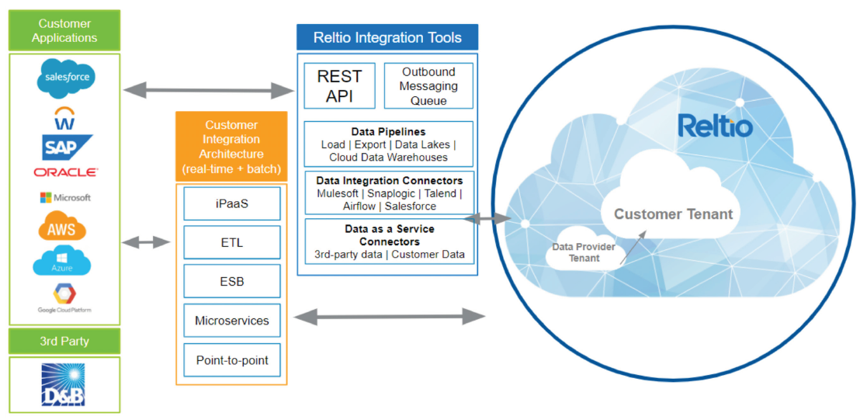

**Technology Disposition Implications**

|  |  |
| --- | --- |
| List All Proposed *New* Technology | Capabilities |
| Reltio MDM | * 100% multi-tenant Cloud Native SaaS platform * Supports all 4 MDM implementation styles * Configurable multi-domain flexible and extensible data model * Role based access control * Row and column level security * Out of the box personalized actionable dashboards and reports * Rest API based inbound and outbound data access * Record enrichment * Configurable attribute validation rules * Taxonomy and Hierarchy Management * Detailed Reporting on History and Transactions * Search, Filter & Views * Powerful workflow capability * Data Quality improvement capability * Match, merge, and link capability * Integration to and from multiple data sources * Multiple external connectors like D&B, Loqate etc * Easy to access relationship between the domains using graph |

|  |  |
| --- | --- |
| List All Proposed *Contained* Technology | Capabilities |
| None |  |

**Integration Implications**

Expected Integration Scenarios

|  |  |
| --- | --- |
| Integration Category | Expected Use |
| API Integration | Yes |
| SOAP Integration | No |
| Queue Integration | No |
| ETL Integration | Yes |
| FTP Integration | Yes |

**Data Implications**

There will not be any data impacts for standing up MDM platform at National Grid

**Security Implications**

Reltio is trusted vendor in MDM space. In the middle of Base Security assessment and so far we have not found any security issue.

**Other Non-Functional Implications**

Not known currently

**Infrastructure Implications**

Azure based SaaS solution so we must make firewall changes for the secured connectivity between the National Grid network and Reltio MDM platform.

**Commercial Implications**

The following is the pre-negotiated budgetary license cost.

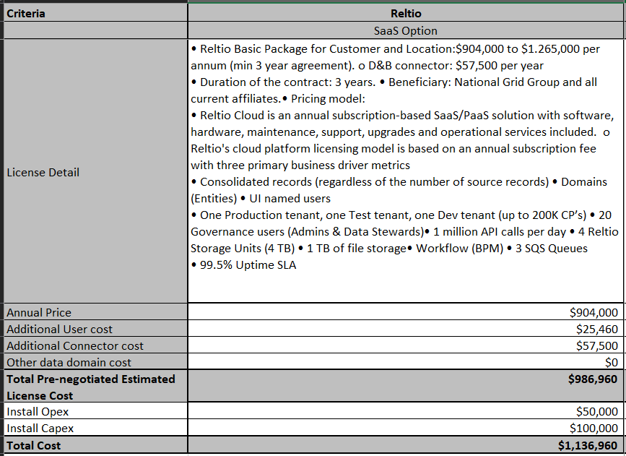

**Note:** The above cost is to enable Master Data Management capability at National Grid by standing up MDM platform. When MDM solution for a specific business domain is implemented, at that time there will be additional implementation cost and separate business case.

**Pros/Cons**

|  |  |
| --- | --- |
| Pros | Cons |
| * 100% cloud native SaaS solution * Cloud SaaS Platform is updated automatically by Reltio and is completely free * NoSQL Based Architecture designed to scale with volume, handle all kinds of structured and unstructured Data * Single multi-domain Unified Data Management Platform enabling MDM * Integrated Analytics and AI to drive Insights and Automation * License and support cost is less than Informatica * Better uptime 99.95% SLA vs Informatica 99.5% * One UI for both business functionality and configuration | * No Azure supports * New tool for National Grid so it requires additional expertise and knowledge * Workflow configuration is not BPML compliance * Out of the box pre-configuration (Accelerator) is not available for the faster implementation * No direct connectivity with Informatica CDQ and Data Catalog |

## Option 2: Informatica MDM Platform

**High Level Informatica MDM Platform Architecture**

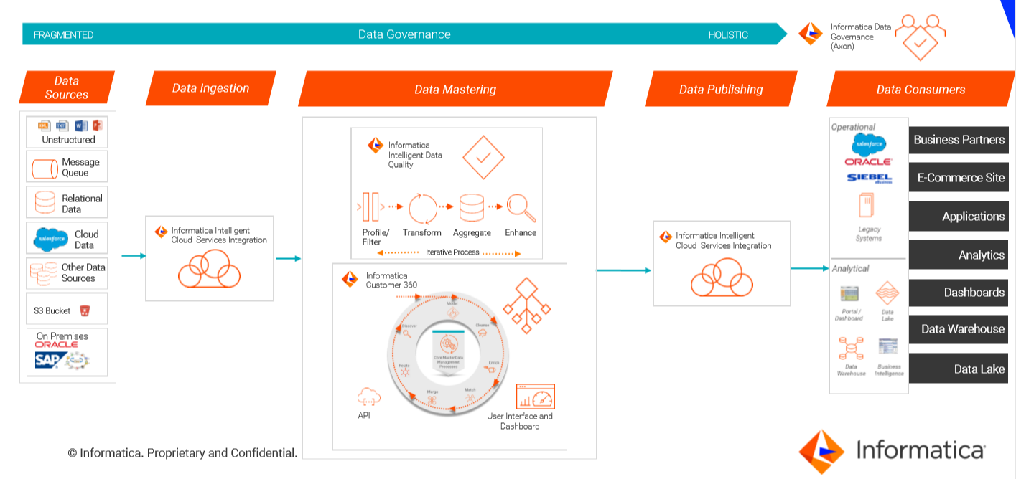

**Technology Disposition Implications**

|  |  |
| --- | --- |
| List All Proposed *New* Technology | Capabilities |
| Informatica MDM | * Azure or AWS based single tenant SaaS platform or client manage platform * Supports all 4 MDM implementation styles * Rich pre-configured Customer 360 data model * Pre-defined Roles and Privileges (Admin/Analyst/Manager) * Pre-built chart configurations * Views Rich business friendly read-only views for entities like Person and Organization * Widget Hierarchy manager widget for data stewards. Easily navigate between entities in a hierarchy. * Match Integrated External Match wizard to find overlap between an external dataset and data in the hub * Wizard Pre-built facility for data stewards to import data * Integration Pre-built integration to view data in Product 360 * Pre-configured workflows * Pre-built DaaS functions (address, email, phone) * Pre-built D&B adapter |

|  |  |
| --- | --- |
| List All Proposed *Contained* Technology | Capabilities |
| None |  |
|  |  |

**Integration Implications**

Expected Integration Scenarios

|  |  |
| --- | --- |
| Integration Category | Expected Use |
| API Integration | Yes |
| SOAP Integration | No |
| Queue Integration | No |
| ETL Integration | Yes |
| FTP Integration | Yes |

**Data Implications**

There will not be any data impacts for standing up MDM platform at NationalGrid

**Security Implications**

Informatica is trusted vendor in MDM space. Security assessment is going on so we will learn more once it is completed but so far there is no issue found.

**Other Non-Functional Implications**

None known at this time

**Infrastructure Implications**

Azure based SaaS solution so we must make firewall changes for the secured connectivity between the National Grid and Informatica MDM platform.

**Commercial Implications**

The following is the pre-negotiated budgetary license cost.

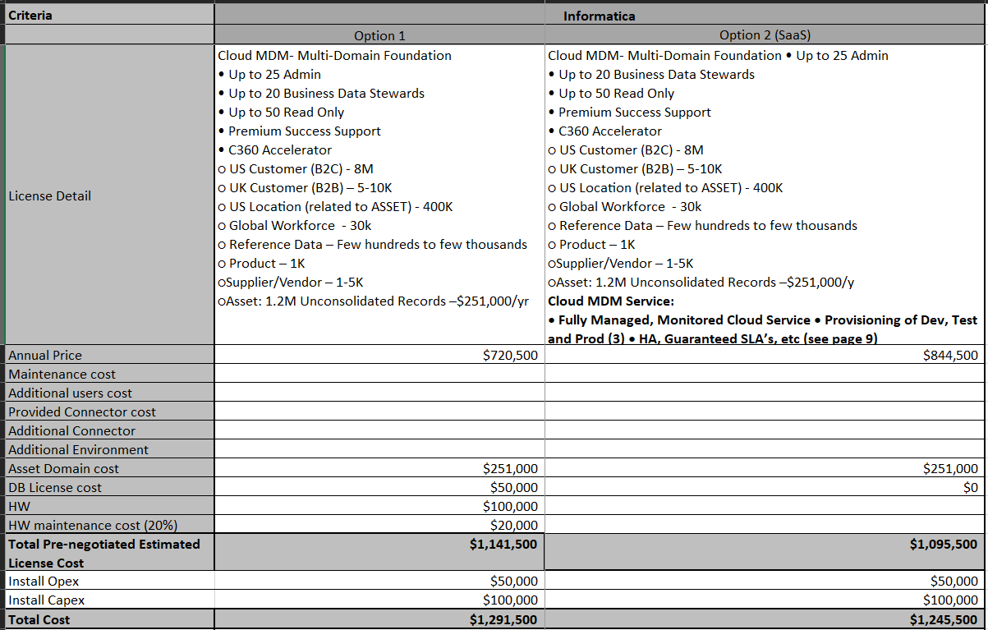

**Note:** The above cost is to enable Master Data Management capability at National Grid by standing up MDM platform. When MDM solution for a specific business domain is implemented, at that time there will be additional implementation cost and separate business case.

**Pros/Cons**

|  |  |
| --- | --- |
| Pros | Cons |
| * NG is using multiple Informatica data tools so Informatica is known to end users * Leader from last few years in the Gartner MDM magic Quadrant * Single tenant environment so better for data security * Supports all 3 major cloud providers like AWS, Azure and GDP * Single multi-domain Unified Data Management Platform * Integrated matured Analytics and AI to drive Insights and Automation * Supports for both structured and unstructured data * Best data quality functionality in the market * BPML compliance workflow * Data Masking on display * Easy to configure new derived fields | * Even though Informatica support SaaS model, it is not 100% cloud native solution * Solution is built on relational database compared to new NoSQL or Big Data based technology * Cost is higher than Reltio * Uptime SLA is 99.5% compared to Reltio 99.7% |

# Recommended Option and Rationale

We don’t have any recommendation as of now.

The comparison of the both platforms are in attached document:

[Top 2 MDM tools Comparision](https://teams.microsoft.com/l/file/085081A6-2D36-4278-9F51-38202B193692?tenantId=f98a6a53-25f3-4212-901c-c7787fcd3495&fileType=xlsx&objectUrl=https%3A%2F%2Fnationalgridplc.sharepoint.com%2Fsites%2FGRP-INT-Architecture%2FShared%20Documents%2FData%20and%20Information%20Architecture%2FMaster%20Data%20Management%2FMDM%20top%202%20Tools%20Comparision%20v2.0.xlsx&baseUrl=https%3A%2F%2Fnationalgridplc.sharepoint.com%2Fsites%2FGRP-INT-Architecture&serviceName=teams&threadId=19:0208706c699049ac805a806775adce1f@thread.skype&groupId=6e41877a-9b63-4354-b522-463045e111f7)

The final selection of the Master data management tool is based on vendor demos, procurement cost, and security assessment.

The weightage for the MDM tool selection will be following:

1. 40% - Team score based on demo
2. 40% - Tool cost based on procurement negotiation
3. 20% - Security assessment score

# Recommended solution

Discuss alignment to the following….

|  |  |  |  |
| --- | --- | --- | --- |
|  | Critical Success Factors | Assessment of Initiative | Description / Add’l Information |
| Business | Supports rapid business change | Yes No N/A  Unknown |  |
| Promotes self service | Yes No N/A  Unknown |  |
| Supports real time transactions | Yes No N/A  Unknown |  |
| Scalable and flexible solutions | Yes No N/A  Unknown |  |
| Business Process Improvement | Yes No N/A  Unknown |  |
| Technology | Aligns to Reference Architecture |  |  |
| Security | Yes No N/A  Unknown | Security assessment is going on and we will know more as soon as it is completed. |
| Application | Yes No N/A  Unknown |  |
| Infrastructure | Yes No N/A  Unknown | Azure based SaaS solution |
| Presentation | Yes No N/A  Unknown |  |
| Leverages National Grid IT Strategy | Yes No N/A  Unknown |  |
| Develops repeatability | Yes No N/A  Unknown |  |
| Enables technology reuse | Yes No N/A  Unknown |  |
| Finance | Viable technologies | Yes No N/A  Unknown |  |
|  | Reduces business costs | Yes No N/A  Unknown | Eventually it should reduce the cost as not required to manual data fix and multiple copy of same data are not required |
| Assessment of Total Cost of Ownership | Yes No N/A  Unknown | We only have estimated cost at this point for standing up the tool |
| Cost to implement and deploy | Yes No N/A  Unknown |  |
| Operations | High availability and predictability | Yes No N/A  Unknown |  |
|  | Partner with reliable technology vendors | Yes No N/A  Unknown |  |
| Develops integrated technical processes | Yes No N/A  Unknown |  |
| Technology that reduces business dependency on IS | Yes No N/A  Unknown |  |